If..else
This syntax is having two blocks
- if block
- else block
if condition:  statement-1  statement-2  else:  statement-3  statement-4  statement-5 | 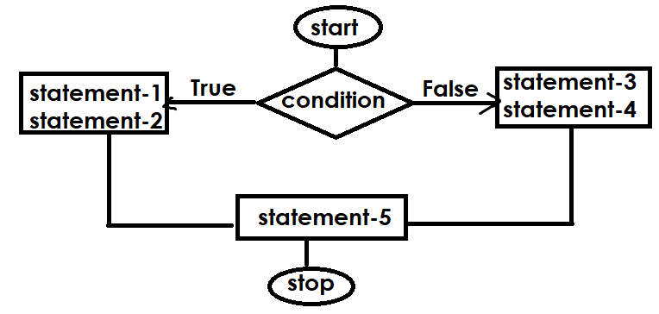

# Write a program to find input number is even or odd

num=int(input("Enter any number "))
if num%2==0:
print(num,"is even")
else:
print(num,"is odd")

Output
Enter any number 5
5 is odd

Enter any number 8
8 is even

Example:
# Write a program to find max of two numbers

n1=int(input("Enter First Number "))
n2=int(input("Enter Second Number "))
if n1>n2:
print(n1,"is max")
else:
print(n2,"is max")
Output
Enter First Number 10
Enter Second Number 20
20 is max

Enter First Number 30
Enter Second Number 20
30 is max

Example:
# Write a program to find input number is 3 digit or not
num=int(input("Enter any number "))
if num>=100 and num<=999:
print(num,"is 3 digit number ")
else:
print(num,"is not 3 digit number")

Output
Enter any number 450
450 is 3 digit number

Enter any number 1400
1400 is not 3 digit number

Example:
# Write a program to find last digit of input number
# is divisible with 3 or not

num=int(input("Enter any number "))
last_digit=num%10
if last_digit%3==0:
print(num,"last digit is divisible with 3")
else:
print(num,"last digit is not divisible with 3")

Output
Enter any number 126
126 last digit is divisible with 3

Enter any number 179
179 last digit is divisible with 3

Enter any number 125
125 last digit is not divisible with 3

https://www.codechef.com/problems/CHRISTGREET
day=int(input())
if day==25:
print("CHRISTMAS")
else:
print("ORDINARY")

https://www.codechef.com/problems/IDESM
# cook your dish here
day=int(input())
if day==15:
print("YES")
else:
print("NO")

https://www.codechef.com/problems/MANGOLASSI
temp=int(input())
if temp>35:
print("YES")
else:
print("NO")

https://www.codechef.com/problems/CHEFPAROLE
days=int(input())
if days>=7:
print("YES")
else:
print("NO")

https://www.codechef.com/problems/ADVITIYA1
day=int(input())
if day>=1 and day<=18:
print("ADVITIYA")
else:
print("WAITING FOR ADVITIYA")

if..elif..else (if..else ladder)
This syntax allows checking multiple conditions.
Syntax:  if condition1:  statement-1  elif condition2:  statement-2  elif condition3:  statement-3  ….  else:  statement-n  if condition1 is True, python runtime executes statement-1  if condition1 is False, condition2 True  python runtime executes statement-2  if condition1,condition2 are False and condition3 is True, python runtime executes statement-3  if all conditions are False, python runtime executes statement-n | 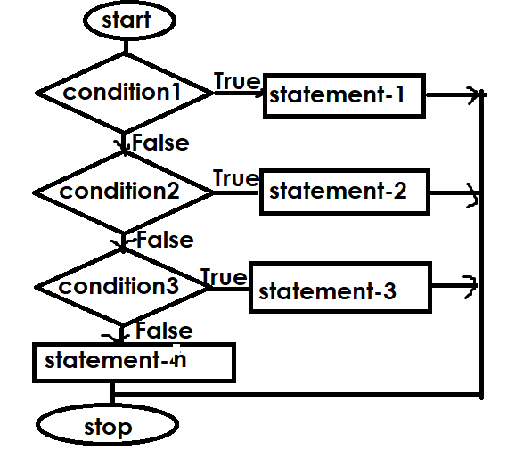

https://csiplearninghub.com/python-if-else-conditional-statement-practice/

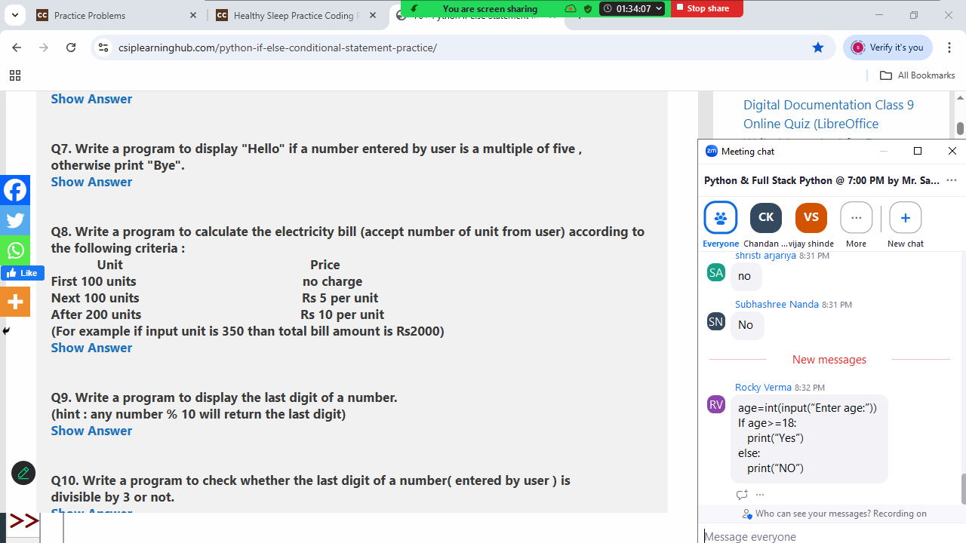

units=int(input("Units :"))
if units<=100:
bill=0
elif units>100 and units<=200:
bill=(units-100)*5
else:
bill=0+500+(units-200)*10

print("Bill Amount is ",bill)

Example:
# Write a program to find input number is +ve,-ve or zero

num=int(input("Enter Number :"))
if num>0:
print("+ve")
elif num<0:
print("-ve")
else:
print("zero")

Output
Enter Number :100
+ve
Enter Number :-100
-ve
Enter Number :0
zero

